# Software Requirements Specification

# for

# ONLINE LIBRARY MANAGEMENT SYSTEM

Version 1.2 approved

Prepared by AYUSH DEV

CSE TMSL

11-08-2023

# Table of Contents

Table of Contents 2

1. Introduction 4

1.1. Purpose 4

1.2. Scope 4

1.3. Existing applications: 4

1.4. References 4

2. Overall Description: 5

2.1. Product Perspective: 5

2.2. User Classes and Characteristics 5

2.3. Software Requirements: 5

2.4. Hardware Requirements: 5

2.5. Customer Survey (Link to Survey Form) 5

3. Functional Requirements 7

3.1. User Registration and Authentication 7

3.1.1. Sign Up 7

3.1.1.1.1. For User 7

3.1.1.1.2. For Librarian 7

3.1.2. Email Verification 7

3.1.3. Password Reset 7

3.1.4. Log-In 8

3.2. Profile Management 8

3.2.1. Profile Creation 8

3.2.2. Profile Deletion 8

3.2.1. Edit Profile 8

3.3. Manage Books for User 8

3.3.1. Books Issued 8

3.3.2. Search Books 8

3.3.3. Issue Books 9

3.3.4. Renew Books 9

3.3.5. Return Books 9

3.3.6. Reserve Books 9

3.3.7. Fine 9

3.3.8. Review/Rate Books 9

3.3.9. Add to Favorites 9

3.4. Recommend Books 9

3.5. Manage Books by Admin/Librarian 9

3.5.1. Add Books 9

3.5.2. Update Books 10

3.5.3. Remove Books 10

3.5.4. Approve Returns 10

3.5.5. Issue Fine 10

4. Non-Functional Requirements 10

4.1. Performance Requirements 10

4.2. Security Requirements 10

4.3. Scalability Requirements 10

4.4. Usability Requirements 10

4.5. Compatibility Requirements 10

5. Assumptions & Dependencies 11

6. Design & Implementation Constraints 11

7. Conclusion 11

# Introduction

The project “Library Management System” is developed to manage and store books information electronically according to readers’ needs. The system helps both students and library manager to keep track of all the books available in the library. It allows both the admin and the reader to search for the desired book.

## Purpose

The purpose of this SRS is to define the comprehensive set of requirements for the development of a feature-rich and user-friendly Library Management System. The platform will facilitate seamless access to the library site through the internet, scattered throughout the library for sending request, receiving information about current status of the books or renewing them.

## Scope

The software will reflect all the requirements defined by the customer. This system will allow to perform all necessary procedures for librarians and students. According to customer requirements, the software to be developed will consist of these databases:

* Item’s database (books, journals, magazines, newspapers, thesis, research papers, previous year papers etc.)
* User’s database
* A small access based database with information about digital items that college has integrated with item’s database.

## Existing applications:

Here is a list of some similar platforms widely used by the people:

* Kindle
* WattPad
* Goodreads

## References

* <https://www.studocu.com/>
* <https://www.academia.edu/>
* <https://github.com/kenil0811/Library-management-system/blob/master/SRS.pdf>
* <https://www.slideshare.net/>

# Overall Description:

## Product Perspective:

The Social Media platform will operate as a standalone web-based application, interacting with external services for functionalities such as authentication through providers and content sharing through APIs.

## User Classes and Characteristics

* **Regular Users:**
  + Age: 10 years and above.
  + Technical Proficiency: Basic computer literacy and familiarity with web applications.
  + Usage Frequency: Daily or frequent usage.
* **Administrators:**
  + Role: Platform moderators and support personnel.
  + Technical Proficiency: Advanced knowledge of the platform's backend systems and moderation tools.

## Software Requirements:

* A database like DBMS (MySQL) to store the details of the users.
* A web browser like Chrome or the app of the said application.

## Hardware Requirements:

* A device (Computer/ laptop/ android/ iOS) with at least 2 GB RAM
* Hard disk space required - 250 MB

## Customer Survey [(Link to Survey Form)](https://forms.gle/Rcgmnwep1nc1ZqqZA)

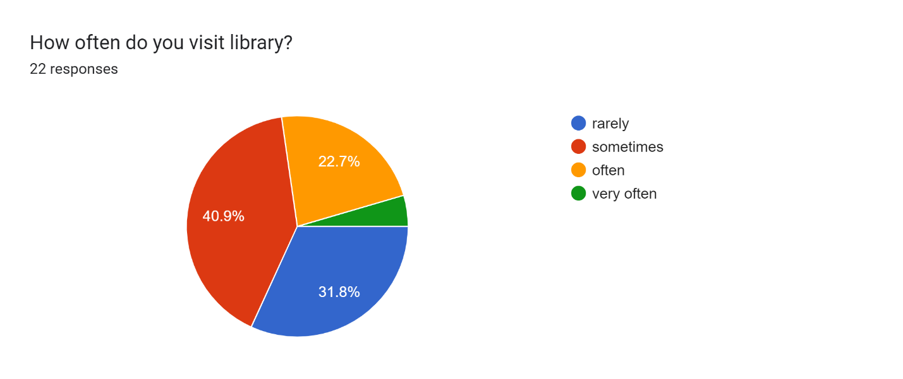

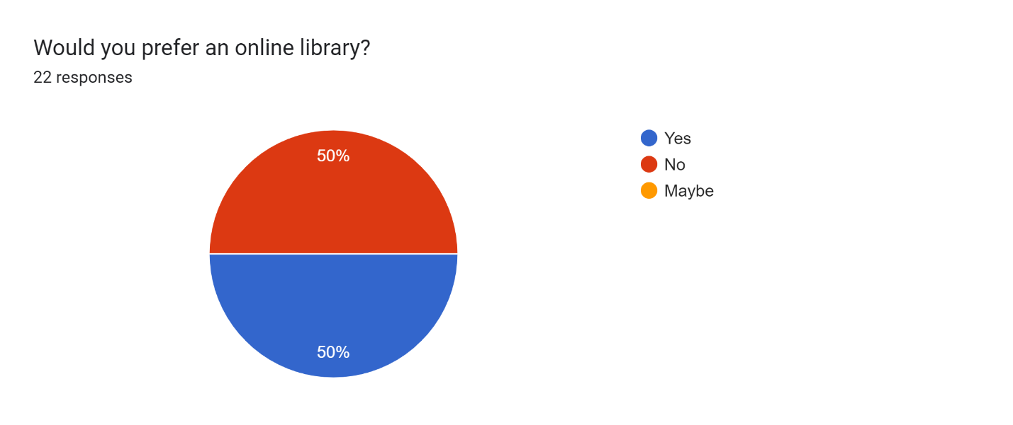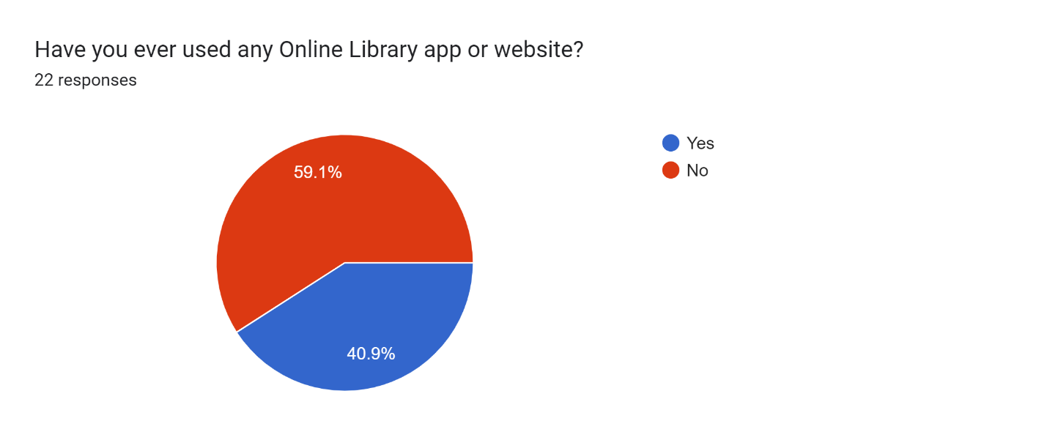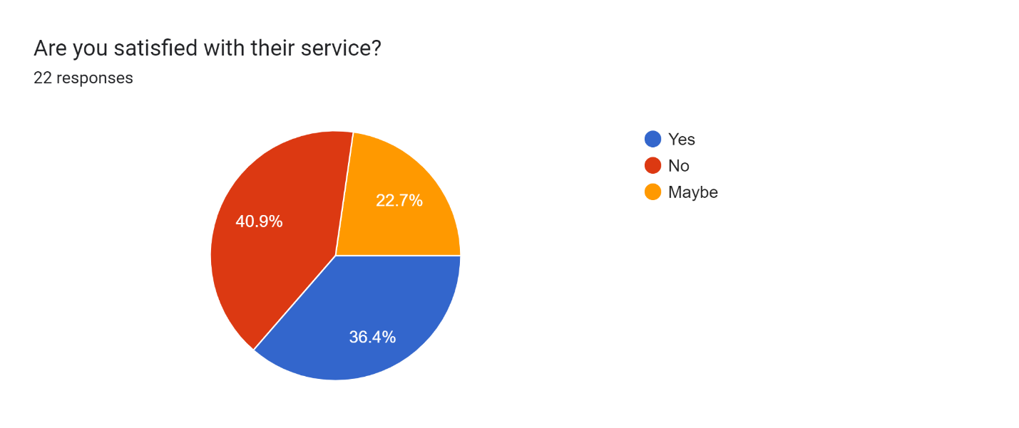

# Functional Requirements

## User Registration and Authentication

### Sign Up

* Users shall be able to register for an account using a valid email address or through social media accounts (Google, Facebook).

##### For User

* **Input**:
* Name of user
* Date of birth
* Address
* Contact details
* Create password
* Re-enter password
* Captcha
* **Output**: OTP is sent to the registered email-id/phone no. consisting of membership ID.

##### For Librarian

The librarian/admin shall be able to login to the portal.

* **Input**:
* Name
* Contact details
* Contact details of library
* Admin ID
* Password
* **Output**:

Admin/Librarian shall be able to login with their ID and password.

### Email Verification

* **Input**: Users shall receive an email with a verification link after registration.
* **Output**: Clicking the verification link shall mark the account as verified and enable login.

### Password Reset

* Users shall be able to reset their passwords securely if they forget their login credentials.
* **Input**: Go to “Forget Password”. Choose to reset password via OTP sent to the registered email ID or mobile no.
* **Output**: Password has been changed to a new password.

### Log-In

* **Input**: User enter their log-in credentials.
* **Output**: The user is logged-in.

## Profile Management

### Profile Creation

* Users shall be able to create and manage their profiles, including personal information.
* **Input**: Users shall fill in the following details:
* Education details
* Profile Picture
* Preferred genre
* Preferred languages
* Favorite books
* **Output**: Profile is created.

### Profile Deletion

* Users shall have the option to delete their profiles and associated data.
* **Input**: Go to “Delete Profile” option. Enter your password for verification.
* **Output**: Profile has been deleted.

### Edit Profile

* Users shall have the option to edit their profiles and associated data.
* **Input**: Go to “Edit Profile” option. User can edit or update the following details:
* Profile picture
* Phone no.
* Email ID
* Address
* **Output**: Profile has been updated.

## Manage Books for User

### Books Issued

* Users will be able to see their issued books along with the due date of return.

### Search Books

* **Input:** Enter the name of author or the name of book to search.
* **Output:** All related books will be displayed according to the searched keyword.

### Issue Books

* **Input:** Click on the book the user wants to issue.
* **Output:** Confirmation on the selected book to be issued. Display an apology message in case the book is unavailable.
* **Output:** If available, the selected book is issued to the user from the library.

### Renew Books

* **Input:** Select the book from the “books issued” section which the user wants to renew.
* **Output:** Display a confirmation message if the book is not reserved by any other user. Else display a message showing the book is reserved by another user.

### Return Books

* **Input:** Select the book(s) from the issued books to return.
* **Output:** A date is displayed within which the user is expected to return the book to the library.
* **Output:** Issued list will be updated and a confirmation message is displayed after the book is returned to the library.

### Reserve Books

* **Input:** Enter the details of the book the user wants.
* **Output:** The selected book is successfully reserved.

### Fine

* **Input:** Check for the fines for the books not returned on due date.
* **Output:** Show details about the fines on different books @ Rs 10/day after the due date.

### Review/Rate Books

* **Input:** Select the book the user wants to review/rate and post a review/give a rating.
* **Output:** The rating/review is posted and shown to the other users.

### Add to Favorites

* **Input:** Select the book(s) you want to add to favorite/read list.
* **Output:** The selected book is added to favorites section.

## Recommend Books

* **Output**: Provide personalized book recommendations based on issued books, search history, favorites, reading habits etc.

## Manage Books by Admin/Librarian

### Add Books

* **Input:** The librarian can add details of the new books of the library including the author’s name, publication etc.
* **Output:** The added book is added and listed to the database with a confirmation message.

### Update Books

* **Input:** Give any update on the books for example: issued, reserved, due, not available etc.
* **Output:** The update is added and displayed to the user.

### Remove Books

* **Input:** Librarian has access to remove any outdated book from the library.
* **Output:** The book is removed from the available books.

### Approve Returns

* The librarian can approve for the return of the books and make it available for the other users to issue.

### Issue Fine

* **Input:** Issue fine for books that are not returned in due time.
* **Output**: Fine is reflected in the user’s profile.

# Non-Functional Requirements

## Performance Requirements

* The platform shall aim for an average response time of less than 1 second for most interactions.
* The platform shall handle concurrent user interactions efficiently without significant delays.

## Security Requirements

* User passwords shall be securely hashed and stored in the database.
* All data transmissions shall be encrypted using HTTPS.

## Scalability Requirements

* The platform shall be designed to accommodate growth in user base and content volume.
* Implement horizontal scaling to handle increased traffic and load.

## Usability Requirements

* The user interface shall be intuitive and user-friendly, adhering to industry best practices for web design.
* The platform shall be accessible to users with disabilities, complying with Web Content Accessibility Guidelines

## Compatibility Requirements

* The platform shall be compatible with various screen resolutions, devices, and browsers to ensure a consistent user experience.

# Assumptions & Dependencies

**Assumptions:**

* Users have basic computer literacy and familiarity with web applications.
* Users will comply with community guidelines and terms of service.
* Users will have access to a stable internet connection for using the platform.

**Dependencies:**

* The platform shall integrate with third-party services for social media login (e.g., Google, Facebook) and content sharing (e.g., Twitter, Instagram).
* The platform's hosting environment must support the required hardware and software specifications.
* The platform's database system must be scalable and capable of handling a growing user base and content volume.

# Design & Implementation Constraints

* The platform's user interface shall be designed following a mobile-first approach to ensure responsiveness and optimal user experience on mobile devices.
* Additionally, the platform shall be developed using industry-standard programming languages and frameworks, adhering to best practices for security and performance.

# Conclusion

In conclusion, the Software Requirements Specification (SRS) for the Library Management System lays out the detailed plan for creating a user-friendly and efficient library system. It explains how the system will handle tasks like borrowing and returning books, and how users will interact with it.

The SRS also emphasizes the importance of keeping user data safe and making sure the system runs smoothly even as more people use it. It mentions using modern tools to analyze data and help library administrators make smart choices. Ultimately, the SRS is a step towards creating an efficient Library Management System. It aims to make libraries even better by using technology in clever ways, making library tasks easier, and giving users a great experience.